GENERAL EDUCATION AND TRAINING CERTIFICATE

NQF LEVEL 1

ABET LEVEL 4 SITE-BASED ASSESSMENT

LEARNING AREA:LANGUAGE LITERACY AND COMMUNICATION: ENGLISH
CODE :LCEN4TASK:TESTDURATION:3 HOURSMARKS:50

This assessment task consists of 6 pages.

INSTRUCTIONS AND INFORMATION

1. | This test consists of THREE sections:

SECTION A: Comprehension

SECTION B: Language in use, visual text

SECTION C: Essay and shorter writing texts

2. | Answer ALL the questions.

3. | Read ALL the questions carefully.

4. | Number the answers according to the numbering system used in this assessment task.

5. | Write neatly and legibly.

SECTION A

QUESTION 1

Read the following text carefully and answer the questions:

5  10  15 | UNHAPPY DAYS  By Thabiso Mothutsi  My life was very unhappy. At night I went to bed with a heavy heart because my hungry stomach and my mother's boyfriend's harsh words kept me awake. He was always finding fault with me and was very strict. I think he didn't like me because I was the only son of my mother, the rest were all girls. Maybe he did not like the idea of another man in the house, although I was still a boy.  I did not know where my father was. My mother said he left us a long time ago, when I was a baby. One day, after my mother's boyfriend beat me, I decided to run away.  I went to the shopping centre near the school. The security guard was friendly and bought me food by four o'clock on the afternoon of that first day. He asked about my family, and I lied: said my father had died and was waiting for my aunt to arrive on the taxi. When it got dark, I walked away.  I met a boy that I knew, Justice, while I was walking around. People in town were always saying that he was a bad influence on their children. He said I should go with him because he knew where to get money. We went on a taxi to Sunnyside. One flat, near the fire escape on the fourth floor, was dark. We took the lift to the fourth floor. Justice had a heavy piece of metal wrapped in a cloth. He broke the small window near the front door and put his hand in to unlock the door. We ran in quickly.

20  25 | The fridge was full of food and we shoved things into a large shopping bag that was hanging behind the door: slices of pizza in a box, polony and two loaves of bread. Justice found a sports bag in the bedroom and grabbed CD's from the shelf and put them in my pocket. We ran out.  The lift would have been too slow, so we ran down four sets of stairs. But when we got into the lobby, a police car pulled up. We tried to run away, and threw the bags down, but we got caught and were taken to jail.  [Adapted from: English Works, Workbook 1, Level 4, page169]

1.1 | Who is the author of this article? |  | (1)

1.2 | Quote a phrase in lines 1 – 5 which has the same meaning as sad. |  | (2)

1.3 | Choose the correct answer from those given below to support the following statement:  The young boy turned into a street kid when he could no longer enjoy life at home.

 | A  B  C  D | He depended on the security guard for food.  He stole from other people's homes.  He ran away from home and had nowhere else to live.  His father had spoiled him while he was a baby. |  | (1)

1.4 | State the difference between a shopping centre and a shop. |  | (1)

1.5 | What do you think was the reason for Justice to cover the heavy piece of metal with a cloth before breaking the window? |  | (1)

1.6 | Explain why the name 'Justice' seems not suitable for the boy. |  | (2)

1.7 | On which floor of the building was the flat where they stole food from? |  | (1)

1.8 | Give a word that would be used by the police in court to refer to the bags that carried the stolen goods. |  | (1)  [10]

 | TOTAL SECTION A: |  | 10

SECTION B (LANGUAGE)

QUESTION 2

Read the following text carefully and answer the questions:

5  10  15  20 | BEING beautiful IS HARD WORK! …  especially for your wallet  The evolution of the beauty industry has come a long way, since the days when women straightened their hair with hot stones. Now we have 10% hair weaves eyebrow threading, manicures and pedicures. All these terms sound so fancy and expensive. And you're right, the beauty industry rakes in millions from people wanting to look and feel better about themselves.  Wendy, from Berea, said she never compromises on her monthly routine. 'I can cut the budget elsewhere, but not everywhere. At the end of the day, I'm the one who wakes up and go to work for this money.  'My weave costs about R4 000, but its reusable. Nails and waxing add up to R600 per month,' Wendy said. 'I feel good about myself after all this and I won't compromise on it.'  Yoli says, 'I'm a big fan of pampering myself, so every second month I'll have a spa day or a full-body massage, which doesn't come cheap,' she said. She said she does not feel guilty about taking care of herself. She said she taught herself how to manufacture her own handmade, natural beauty products.  She said, 'I don't want to calculate how much I spend on manicures and pedicures because I do those frequently. I buy expensive make-up, but at least it lasts me up to three months, so it's not a monthly expense.' But when she was asked to add up her beauty monthly expenses, she refused to do it, saying, 'I don't want to see it as a bad thing.'  [Adapted from: Sunday Sun, 24 April 2016]

2.1 | Give a word that has an opposite meaning to 'better' in line 5. |  | (1)

2.2 | Rewrite the following sentence in reported speech.  'I'm a big fan of pampering myself,' she said.  Begin with: She said that … |  | (3)

2.3 | Give ONE word for the following descriptions:

 | 2.3.1 | A person who helps clients with their make-up at a beauty salon. |  | (1)

 | 2.3.2 | A person whose job is to cut client's hair. |  | (1)

2.4 | Give ONE word which has the same meaning as the following expression:  'Being beautiful is hard work, especially for your wallet.' |  | (1)

2.5 | Rewrite the following sentence and write the underlined word in full.  I won't compromise on how much I spend to look beautiful. |  | (1)

2.6 | Join the following sentences by using the word in brackets:  Why are ladies so ready to pay for being beautiful? Being beautiful is so expensive. (if) |  | (2)  [10]

QUESTION 3

Study the following picture carefully and answer the questions:

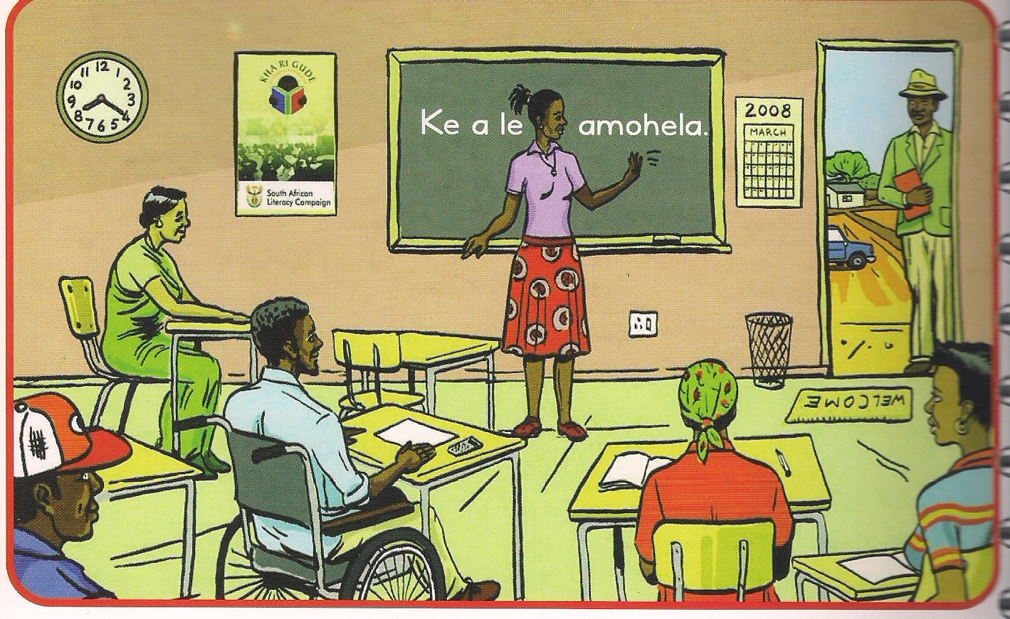
[Adapted from: Kha ri Gude Literacy manual, page 2]

3.1 | Explain what is happening in the picture. |  | (1)

3.2 | Do you think the man standing at the door will be allowed to come in? Explain your answer. |  | (2)

3.3 | How does the picture inform us that the situation is inclusive? |  | (1)

3.4 | Choose the correct word(s) from those given in brackets. Write only the word(s) next to the question number (3.4) in the ANSWER BOOK.  The woman standing in front of the picture will probably be found in (church/school) situation. |  | (1)  [5]

TOTAL SECTION B: |  | 15

SECTION C

Answer only TWO sub-questions from this section – ONE essay and ONE shorter piece.

QUESTION 4: ESSAY

Plan before you write.

Write an essay of about ONE to ONE-AND-HALF pages on ONE of the following topics:

4.1 | My favourite TV programme |  | [15]

OR

4.2 | Water is a scarce resource in our country. Write an essay in which you discuss the importance of saving water and how shortages can be solved. |  | [15]

OR

4.3 | My RDP house – a big disappointment |  | [15]

QUESTION 5: SHORTER PIECE

Choose ONE shorter piece from the following and write for about ONE page in length.

5.1 | Write a letter to a social worker in your area and report a neighbour who is defrauding the government by registering her children for social grants. |  | [10]

OR

5.2 | Complete the following diary entry:  Dear diary  Today I finished writing my examinations and ... |  | [10]

TOTAL SECTION C: |  | 25

GRAND TOTAL : |  | 50

